  
  
**Health and Benefits App**

**Version 7.6  
Launch: 08/27/2024**

Revision History

| Date | Version | Description | Author |
| --- | --- | --- | --- |
| 11/5/2021 | 3.0 | Added VA Vaccine Records functionality | Ashley Matthews |
| 3/10/2022 | 4.0 | Added Payments functionality  Updated Home & Profile screens to include Payment option | Meko Hong/Brenda Rocha |
| 11/08/22 | 5.0 | Added Prescriptions functionality | Esther Kitavi |
| 01/??/2023 | 5.1 | Small changes to Prescriptions and Sign In | Call center team and Meko Hong |
| 02/02/2023 | 6.0 | Added Encouraged Update | Misty Milliron-Grant |
| 02/15/2023  3/1/2023 | 7.0 | Updated content account for new navigation and fixed outdated information; added What’s New alert box | Misty Milliron-Grant |
| 4/18/2023 | 7.1 | Added Digital Decision Letter functionality | Kelly Lein |
| 4/24/2023 | 7.1 | Added bullet under Profile section to include Veterans able to add/edit Preferred name & Gender identity | Meko Hong |
| 10/10/2023 | 7.2 | Added Proof of Veteran Status. Updated the old home page and profile pages with new images and proof of veteran status. Added images to Payments. Updated Table of Content page numbers. Updated formatting. | Adam Kasmier |
| 12/22/2023 | 7.3 | Updated In Person and Phone Appointments content to indicate changes to card view and details view. | Adam Kasmier |
| 1/31/2024 | 7.4 | Updated the Prescriptions section to reflect the recent enhancements to the List view. | Lauren Russell |
| 6/24/2024 | 7.4 | Updated Home section to reflect Personalized Home Screen | Ameet Sarkar |
| 8/2024 | 7.6 | Updated Claims and Appeals section to reflect Claims Phase Expansion | Lauren Russell |

**Table of Contents**

**Overview**

What is the VA Health & Benefits app?

Who can use the VA Health & Benefits app?

How do users find a VA contact center phone number?

**App Functionality**

Sign In

Home

Update available

What’s new

Proof of Veteran status

Benefits

Claims

Disability rating

VA letters and documents

Health

Prescriptions

Appointments

Messages

VA vaccine records

COVID-19 updates

Payments

VA payments history

Direct deposit

Profile

General Errors

Known Issues

**Contact Center Escalation Path**

## 

## **Overview**

### **What is the VA Health & Benefits app?**

The Office of the CTO launched a mobile app that leverages native mobile features to allow Veterans to check the status of their services and complete simple, transactional tasks quickly and easily across health and benefits.

The VA Health & Benefits app combines existing functionality across multiple VA websites in one convenient place. This guide provides a high-level overview of the app experience and outlines some differences between the app and web functionality. For more detailed information on the specifics of each feature, please refer to the existing web product guides.

Through user interviews, high-fidelity usability testing, and collaborative design sessions, the team learned that Veterans would get the most value from the following features in a mobile app:

* **Biometric Sign-In**: Enable face, fingerprint, or iris biometrics as a more convenient method for authentication
* **Veteran Crisis Line**: Access the crisis line with SMS integration
* **Profile**: Review military information and edit personal and contact information, which will also update their profile information on the VA.gov website.
* **Claims and Appeals**: Review claim and appeals statuses and submit evidence supporting their claims
* **Prescriptions**: Review, refill, and track delivery of VA prescriptions
* **Appointments**: Review or cancel health care appointments, integrated with native phone features (e.g., users can add their appointments to their phone’s calendar app and use their phone’s maps app to get directions to their appointments).
* **Messages**: Communicate with VA health providers directly through the app
* **Vaccine Records:** Review VA vaccine history
* **Letters**: Download common VA letters and documents
* **Payments:** Review payments made by the VA and update direct deposit information
* **Facility Locator**: Use phone location services to find the nearest VA facilities

### **Who can use the VA Health & Benefits app?**

To sign in to the VA Health & Benefits app:

* Veterans must download the VA Health & Benefits app from the app store on their mobile device (Apple App Store or Google Play)
* Veterans must sign in with their LOA3 credentials. ID.me, DS Logon, and MHV credentials are all supported.
* Users can use biometric login (touch ID, face ID, face recognition, fingerprint, iris) for fast and easy sign-in. When a user successfully enables biometric sign-in, they can gain access to the app with face, fingerprint, or iris biometrics. This authentication remains valid for 45 days. After 45 days, the user must sign in with their VA credentials.
  + The use of biometrics on the device is optional. If the user opts out, they must sign in whenever they open the app.

### **How do users find a VA contact center phone number?**

Unlike the VA.gov footer, where users have a phone number to call, this app does not have a single phone number that is always accessible. Instead, users can access a phone number when they reach a “dead end” in their experience (i.e. if no claims or messages appear for them in the app).

## **App Functionality**

### **Sign-In**

The app supports four VA credentials (ID.me, Login.gov, MHV, and DS Logon) and must be LOA3. The sign-in experience for each credential type is a web view of the same workflow users experience when signing in to VA.gov or MHV. Users can use biometric login (face, fingerprint, or iris recognition) during the app onboarding process and within the app settings.

**For users with biometric sign-in enabled**:

* App users remain signed in to the app for 45 days. The app will authenticate with their face, fingerprint, or iris recognition during this period.
* Users sign in via biometrics each time they open the app, and the process varies depending on the user’s phone memory and whether apps run in the background.
* After 45 days, users must re-authenticate by signing in to the app with one of their VA credentials.
  + If the user previously opted into biometric sign-in, their preference is saved, and they do not have to re-opt into biometrics.

**For users without biometric sign-in enabled**:

* **If the user has a passcode set on their device**, the app prompts them to enter a passcode, but they do not have to re-authenticate with their username and password.
* **If the user does not have a passcode set on their device, the app prompts them** to re-authenticate with their username and password each time they open the app.

**Resetting Passwords**

* As with VA.gov, only identity providers can reset passwords (ID.me, Login.gov, DS Logon, or My HealtheVet).
* Currently, users are taken outside the app when resetting passwords. After resetting a password, users must return to the app and enter their new credentials to gain access.

**Sign-In Flow (Using ID.me Credentials)**

| **Sign-in Screen 1** | **Sign-in Screen 2**  **(Part a)** | **Sign-in Screen 2**  **(Part b)** | **Sign-in Screen 3** |
| --- | --- | --- | --- |
|  |  |  |  |

*Note: Users will not see the “Internal release for testing only” message in Screen 1.*

| **Sign-in Screen 4** | **Sign-in Screen 5** | **Sign-in Screen 6** | **Sign-in Screen 7** |
| --- | --- | --- | --- |
| **Authentication loading screen** |  |  |  |

#### 

| **Sign-in Screen 8** | **Sign-in Screen 9** | **Sign-in Screen 10** | **Sign-in Screen 11** |
| --- | --- | --- | --- |
| Loading screen | Authentication loading screen |  | App loading screen |

#### 

| **Onboarding Screen 1** | **Onboarding Screen 2** | **Onboarding Screen 3** | **Onboarding Screen 4** |
| --- | --- | --- | --- |
|  |  |  |  |

| **Onboarding Screen 5** |
| --- |
|  |

### 

### **Home**

The Home Screen contains personalized information about Veterans, enabling them to access relevant information and features. It is divided into 3 sections: Activity, About You, and VA Resources. The content and functionality of these sections are described below.

### **Activity**

The Activity section surfaces active or actionable content for Prescriptions, Secure Messages, Appointments, and Claims. The display logic and navigation for these features are listed below:

**Appointments**

* **Display Logic:** If the Veteran has an appointment in the next 7 days, the Home Screen will display a module that reads “Appointments (x this week),” where x represents the number of appointments in the next 7 days.
* **Navigation:** When the Appointments module is clicked, the Veteran will be navigated to the Appointments page.

**Claims**

* **Display Logic:** If the Veteran has an active Claim, the Home Screen will display a module that reads “Claims (x active),” where x represents the number of  
  active claims.
* **Navigation:** When the Claims module is clicked, the Veteran can navigate to the Claims page.

**Messages**

* **Display Logic:** If the Veteran has unread secure messages, the Home Screen will display a module that reads “Messages (x unread),” where x represents the number of unread messages.
* **Navigation:** When the Messages module is clicked, the Veteran will be navigated to the Messages page.

**Prescriptions**

* **Display Logic:** If the Veteran has prescriptions ready for refill, the Home Screen will display a module that reads “Prescriptions (x ready for refill),” where x represents the number of prescriptions ready for refill.
* **Navigation:** When the Prescriptions module is clicked, the Veteran will be navigated to the Prescriptions page.

**Errors**

* If data is not returned from the APIs for any of the features listed above, then the text “We can’t show all activity right now. Check back later” is displayed in red in the Activity section.

### **About You**

This section contains the following elements:

* **Proof of Veteran Status**
* **Disability Rating:** This only displays if the Veteran has a disability rating.
* **Monthly Compensation Payment:** This only displays if the Veteran receives a monthly compensation payment based on their disability rating.

### **VA Resources**

This section contains:

* Information about how to contact the VA
* VA location finder

**Note**: Users don’t have to start on the Home screen to access other main sections of the app (e.g., Benefits, Health, or Payments). The only exception is for Profile, which users can only access from the Home screen.

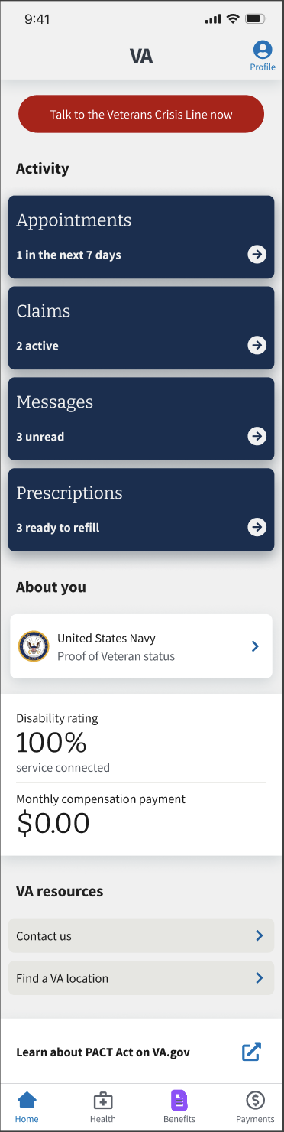

#### **Update available**

Users may find a special message or alert on the Home screen. This alert is to inform users that an updated version of the app is available and to encourage them to update to the latest version.

Users can update the app by tapping the “Update now” button. When they tap this button:

* For iOS users, they will be taken out of the app and taken to the Apple Store.
* Android users' phones will automatically start updating the app.

Users can choose not to update the app by tapping the Skip this update button. When they tap this button, the alert will disappear from their Home screen. It will reappear the next time a new version is released.

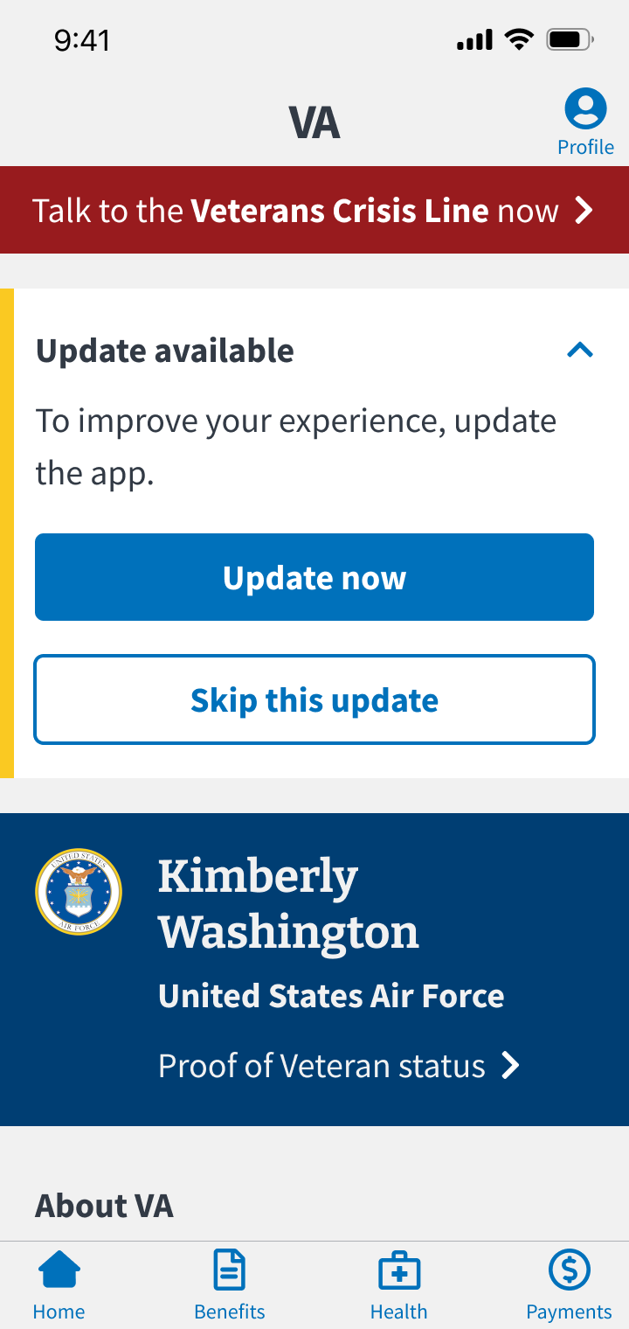

#### **What’s new**

Users may find a special message or alert on the Home screen. This alert informs users of what new features or tools are available in the app.

The alert can be expanded and collapsed. When expanded, the user can dismiss this alert by tapping the Don’t show this again button. Once this button is tapped, the alert will disappear from their home screen and not appear again until we release another feature we’d like to draw their attention to (i.e., this alert will not appear every release).

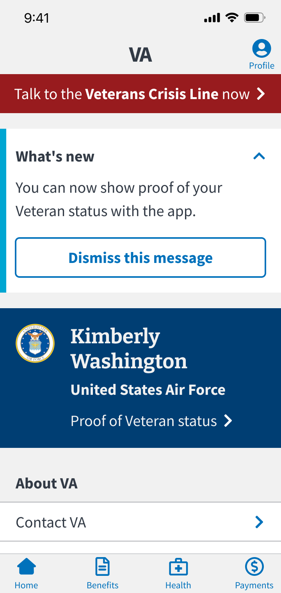

#### **Proof of Veteran status**

Users will find this feature in their name tag under their branch of service called “Proof of Veteran status.” When users tap “Proof of Veteran Status,” they will be taken to a scrollable page that provides details that the Veteran can display to prove they are a Veteran. This page can be used to receive non-VA privileges like discounts on memberships, purchases, etc., that merchants allow.

While similar to the Veteran Identification Card (VIC), this is not part of that program. Dishonorably discharged veterans will not see this feature, and it does not entitle the user to any VA benefits. This page can also be found through the nametag feature on the Profile page.

| **Home Page** | **Veteran Status (Top)** | **Veteran Status (Bottom)** |
| --- | --- | --- |
|  |  |  |

### 

### **Benefits**

The Benefits section includes the following subsections: Claims, Disability rating, and VA letters and documents.

| **Home Page** | **Benefits Home Page** |
| --- | --- |
|  |  |

#### 

#### **Claims**

Users can review their claims and appeals information for existing (active and closed) claims. Users cannot file new claims from the app.

The app currently supports the following claims and appeals types:

* Disability compensation
* Veterans' or survivors pension benefits
* Special monthly compensation
* Dependency and Indemnity Compensation (DIC)
* Burial allowance

Claims features:

* Review active claims
  + Review all of the associated steps and an overview of the activities taking place within each step
  + Understand the status of each step
  + Upload additional files (or evidence) as a result of a File Request or as needed throughout the Claims process
* Review closed claims and appeals details
  + View and download the Claim Decision Letter from a closed Disability Compensation claim
  + All claim types will display from the past 365 days

To review claims, users tap the Benefits icon on the bottom navigation bar (bottom of the screen). In the Benefits section, they tap on Claims. The user will navigate to the Claims landing screen, which has 2 tabs: Active and Closed claims.

Some claims may have an associated Status label displayed on the list item in Claims History. Status labels are displayed to indicate any associated activity:

* Active: More Information Needed—claims that have an outstanding File request
* Closed: Decision Letter ready—decided claims with a downloadable decision letter

| **Home Screen** | **Benefits Landing Screen** | **Claims Landing Screen** |
| --- | --- | --- |
|  |  |  |

When users tap on a claim, they can use the 2 tabs to review the Status and Files associated with the claim.

| **Claims History Screen** | **Claims Status Screen**  **(Open Claim)** | **Claims Details Screen** |
| --- | --- | --- |
|  |  |  |

When a user views a closed Disability Compensation claim, if a Decision Letter has been sent, they can view their Claim Letters. From the Claim Letter List screen, the user can choose the Decision Letter with the decision date matching their closed claim. The Decision Letter can be viewed, downloaded, or shared.

| **Claims Status Screen**  **(Closed Claim)** | **Claims Letters List** |
| --- | --- |
|  |  |

#### **Disability rating**

Users can review their disability rating (both their combined disability rating as well as individual ratings)

To review their disability ratings, users tap the Benefits icon on the bottom navigation bar (bottom of the screen). In the Benefits section, users tap on Disability rating.

| **Home Screen** | **Benefits Landing Screen** | **Disability Rating Landing Screen** |
| --- | --- | --- |
|  |  |  |

#### 

#### **VA letters and documents**

Users can customize and download common VA letters and documents. Within the app, users can:

* Edit address on letters
* Configure information is shown on the Benefits Summary and Service Verification letter
* Download letters

To access VA letters and documents, users tap the Benefits icon on the bottom navigation bar (bottom of the screen). In the Benefits section, users tap on VA letters and documents.

Users must first review the mailing address they’d like to appear on their letter. Users can add/update their mailing address before reviewing their list of letters. Users can then go to the list of letters by tapping the review letters button.

| **Homepage Screen** | **Letters Mailing Address Screen** | **Letters List Screen** |
| --- | --- | --- |
|  |  |  |

| **Letter Configuration  Screen (Part 1)** | **Letter Configuration Screen (Part 2)** | **Generated Letter** |
| --- | --- | --- |
|  |  |  |

### 

### **Health**

The Health section includes the following subsections: Prescriptions, Appointments, Messages, VA vaccine records, and COVID-19 updates.

| **Home Page** | **Health Home Page** |
| --- | --- |
|  |  |

**General Cerner Alert**

Users registered at facilities that have transitioned to using Cerner (an electronic health/medical records system) cannot manage some health care tasks in the app. This alert is shown at the top of the Health landing screen, Appointments landing screen, and Messages landing screen. The alert prompts users to go to the My VA Health portal. Users can tap the Go to My VA Health link to take them from the app to the My VA Health portal.

**Important**: There is a separate Cerner alert for prescriptions, which is noted in the Prescriptions section of this product guide.

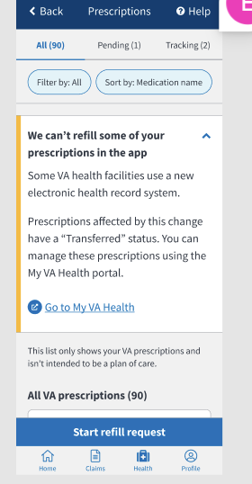

#### 

#### **Prescriptions**

Users can review their VA prescriptions, request refills of their eligible VA prescriptions, and review prescription tracking information. However, they cannot renew prescriptions in the app. The app’s functionality is similar to that found on the MHV website and the RX Refill app.

**Prescription Features**

* Review active and non-active prescriptions
  + Filter and sort prescriptions
  + Review prescription details
* Request a refill of eligible prescriptions
* Review pending (recently submitted or refill in process) refills
* Review trackable refills
  + Review tracking information associated with tracked refills

**Getting to Prescriptions**

To review prescriptions, users tap the Health icon on the bottom navigation bar (bottom of the screen). In the Health section, users tap on Prescriptions. Users are taken to the Prescriptions landing screen, which consists of All VA prescriptions, defaulted to Sort by Status A-Z, and then Medication names, respectively.

There is a Filter and sort button that allows users to customize their view. They can apply a filter option that will display the selected prescription Status type. Users must select the Filter and Sort button below the list title to change this. Users will now find Pending and Tracking filter options in the Filter panel instead of the tab navigation in previous experiences.

Selecting a Sort option will bring a selection with the associated query to the top of the list. The options are to Sort by Fill date, Medication name, Refills left, and Status.

The Filter and Sort panel has options at the top. The user can either Apply to view the updated list or Cancel to return to their previous view.

| **Home Screen** | **Health Screen** | **Prescriptions Landing Screen** | **Prescriptions Filter/Sort** |
| --- | --- | --- | --- |
|  |  |  |  |

**General Errors**

Error screens may appear while the user is using the app. Users should refresh the screen (if the button is present) or check back again later, as this may be due to upstream service issues.

| **Maintenance** | **Something Went Wrong** |
| --- | --- |
|  |  |

**No Prescriptions**

If no prescription list appears for users, this may be due to the following:

1. They don’t have a premium MyHealtheVet account.
2. They don’t have any active prescriptions, *or* their inactive prescriptions have been inactive for more than 180 days.
3. Their prescriptions are controlled substances, were self-entered on MHV, or were administered at a clinic or ER.
4. Their prescription is new and has not yet been updated in upstream systems.

| **Need Premium Account** | **Can’t FindPrescriptions** |
| --- | --- |
|  |  |

**Requesting a Refill**

To request a refill of a prescription, users:

1. Tap the Start refill request button at the top of the Prescriptions screen
2. Select the prescriptions they want to refill in the Refill request screen
3. Tap the Request Refills button at the bottom of the Refill request screen
4. Tap Request Refill in the confirmation screen (this will look different on iPhone and Android phones)

**The Refill request screen only lists refillable prescriptions. Prescriptions may not be refillable if** they have no remaining refills, were recently refilled, are currently being refilled, have expired, or have been discontinued. Users should consult the VA Pharmacy or their prescribing doctor if they believe there is an error with the prescriptions on this list.

They may also be able to determine the cause by looking at the prescription details for that prescription. To do so, they go to the Prescriptions screen list, find the prescription in question, and select Get prescription details. This screen will include details such as the number of refills left and status, which may help them determine why a prescription is not refillable.

Note: Prescription refills will be mailed to the address on file at the user’s local VA pharmacy. Changing their address in the Profile section of the app will **not** change the delivery address. Users should contact their local VA pharmacy to verify or change their prescription address.

| **Prescription Screen** | **Refill Request Screen** | **Selected Prescriptions** | **iPhone Confirmation Screen** | **Android Confirmation Screen** | **Refill Request Summary Screen** |
| --- | --- | --- | --- | --- | --- |
|  |  |  |  |  |  |

**Refill Request Summary Screen**

Once users have confirmed their refill request, they are taken to the Refill request summary screen, which states whether their requests have been successfully submitted. Successful requests will have a green checkmark next to them, while unsuccessful requests will have a red “X” icon next to them.

| **All Successfully Submitted Refills** | **Some Successfully Submitted Refills** | **No Successfully Submitted Refills** |
| --- | --- | --- |
|  |  |  |

When unsuccessful requests are received, users will receive an error message at the top of the screen. They should select the Try Again button to resubmit the unsuccessful requests in the error message.

Note: The summary screen will only list resubmitted prescriptions once resubmitted.

**Refill Request Errors**

If users try to tap the Request Refills button without selecting at least one prescription, they will receive an error message at the top of the screen. They can tap on at least one prescription to dismiss the error message, which allows them to tap the Request Refills button and move forward with their request.

| **Refill Request Screen** | **Refill Error Message** |
| --- | --- |
|  |  |

**Prescription Details**

Users tap the Get prescription details button on any prescription card to get additional prescription details (such as quantity or fill date).

| **Prescriptions Screen** | **Prescription Details** |
| --- | --- |
|  |  |

Note: If a prescription is refillable, a Request Refill button will appear on the details screen, which users can also use to request that prescription’s refill.

**Prescription Statuses**

To review a prescription's status definition, users tap the status tag (on the prescription card or on the prescription details screen).

| **Prescription Screen** | **Prescription Details** | **Status Definition** |
| --- | --- | --- |
|  |  |  |

The prescription statuses and associated definitions are:

| **Active** | Prescription may be available to be refilled (can be refillable or non-refillable) |
| --- | --- |
| **Active: On Hold** | The pharmacy is reviewing the prescription before it can be filled |
| **Active: Parked** | The prescription has been filled, but the doctor hasn’t issued it yet |
| **Active: Refill in Process** | The prescription is being processed or refilled by the pharmacy or on the way to the user |
| **Active: Submitted** | A refill for the prescription has been requested |
| **Active: Suspended** | A prescription that is not scheduled to be filled yet |
| **Discontinued** | A prescription that is no longer available to be filled. |
| **Expired** | A prescription that is too old to be filled. Expired does not refer to the expiration date of the prescription |
| **Non-verified** | A pharmacist is verifying the prescription |
| **Transferred** | The facility that fills the prescription is now a Cerner facility |
| **Unknown** | The status of the prescription can not be determined |

Note: Non-active prescriptions (expired, discontinued) are only displayed for 180 days after expiration or discontinuation.

**Filtering and Sorting Prescriptions**

Users can filter and sort the list to help them find specific prescriptions.

Users tap the filter buttons below the tab bar to filter or sort.

| **Prescription Screen** | **Filter Screen** | **Sort Screen** | **No Matches Found** |
| --- | --- | --- | --- |
|  |  |  |  |

Note: If users select a status from the filter screen and they do not have a prescription with that status in the list, they will get a screen with a “There are no matches” message. Users should select another status from the list or reset the filter to view prescriptions.

**Pending Prescriptions**

The Pending tab will list recently submitted prescriptions (i.e., those with a status of Active: Submitted) and prescriptions that the VA pharmacy is processing (i.e., those with a status of Active: Refill in Process).

Prescription refills may be in process for a few days, depending on how long it takes the VA pharmacy to process and ship them.

To review pending prescriptions, users can either tap:

1. The Pending tab in the top tab bar
2. The Go to all pending refills button in the refill request summary screen

| **Prescription Screen** | **Refill Summary Request Screen** | **Pending Prescriptions** |
| --- | --- | --- |
|  |  |  |

**Tracking Prescriptions**

To review trackable prescriptions, users tap:

1. The Tracking tab in the top tab bar (easiest way).
2. Search for trackable prescriptions in the All tab. Trackable prescriptions will have an additional button on the card that says, “Get prescription tracking.”

Note: The Tracking tab will list prescriptions with tracking information within the last 15 days (from the tracking label creation date), even if they’ve been delivered.

| **Prescription Screen** | **Tracking Prescriptions** |
| --- | --- |
|  |  |

**Tracking Details**

To review tracking details, users tap the Get prescription tracking button on the prescription card for trackable prescriptions (these prescriptions can be found in the All or Tracking tab).

| **Tracking Prescriptions** | **Tracking Details** |
| --- | --- |
|  |  |

Users tap the tracking number to reach the carrier site to review additional tracking information, such as the last location or expected delivery date. Please note that this information may not be available if the prescription recently became trackable (i.e., the shipping label was created but has yet to ship).

**Multiple Tracking Numbers**

Some prescriptions may have multiple tracking numbers. This scenario occurs when multiple batches of the same prescription have been sent within the same 15-day period. Multiple tracking cards (representing packages) will be shown in the tracking details screen (see screenshot below). The packages will be ordered from the most recent ship date to the oldest.

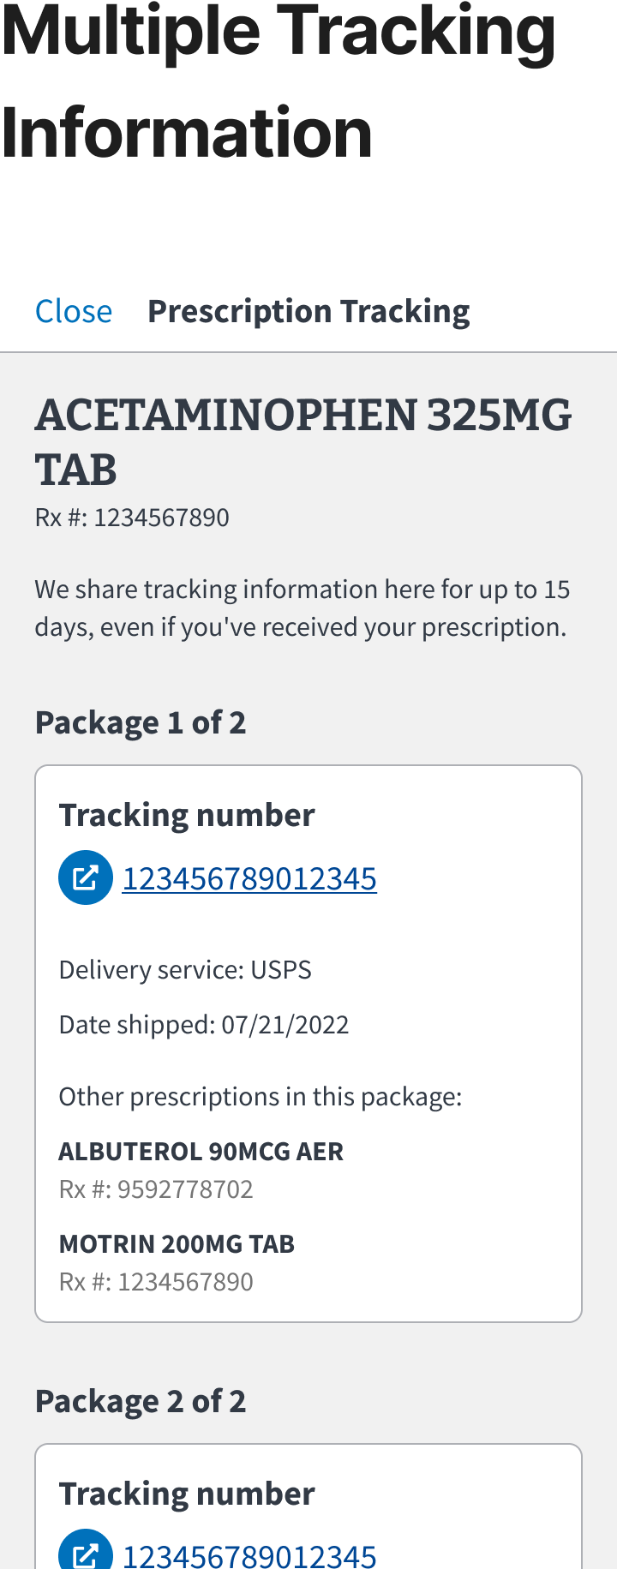

**Prescriptions Affected by Cerner**

Users cannot refill prescriptions prescribed at a facility that has transitioned to Cerner (an electronic health/medical records system). If users have *any* Cerner prescriptions, they are shown a collapsible alert. Users who expand the alert are made aware that Cerner prescriptions are labeled with the Transferred status. Users can manage Cerner prescriptions by tapping the Go to My VA Health link to take them out of the app to the My VA Health portal. (Users can still manage their non-Cerner prescriptions in the app.)

| **Prescriptions Screen (Cerner General Banner alert)** | **Prescription Screen (Message)** | **Prescription Detail Screen (Alert banner)** | **Prescription Detail Screen (Alert message)** |
| --- | --- | --- | --- |
|  |  |  |  |

#### 

#### **Appointments**

Users can review their upcoming (confirmed, pending), canceled, and past appointments.

* Upcoming appointments include all VA appointment types (including community care) over the next 365 days.
* Past appointments will include all appointment types from the past 365 days.
* Users can cancel pending Community Care and VA appointments and confirmed VA appointments.
* Users must keep confirmed Community Care appointments.
* Users cannot directly schedule or request appointments in the app. They must call or visit VA.gov.
* In-Person and Phone Appointments Details will have additional information that Community Appointments and Virtual appointments will not
  + If a field is empty, instead of hiding the field, it will say not noted
  + In Person now includes Clinic Room and Floor if one is known
* In-person and Phone “cards” on the Upcoming Tab now include Type of care and Provider

To review appointments, users tap the Health icon on the bottom navigation bar (bottom of the screen). In the Health section, they tap on Appointments. They are taken to the Appointments landing screen, which has 2 tabs containing upcoming and past appointments.

| **Home Screen** | **Health Screen** | **Upcoming Appointments Screen** | **Past Appointments Screen** |
| --- | --- | --- | --- |
|  |  |  |  |

| **Upcoming Appointment Details** | **Canceled Appointment Details** | **Past Appointment Details** |
| --- | --- | --- |
|  |  |  |

#### 

#### **Messages**

Users can use secure messages to communicate with their health care team. This functionality in the app is a limited version of the web-based Secure Messaging MHV experience. In the app, users can:

* Review messages
* Reply to messages
* Compose and send a new message
* Compose and save a draft message
* Attach a file to a message
* Move messages to and from folders
* Delete messages
* For all other functionality, users must use MHV on the web

Noted differences between the app and web-based MHV version:

* User Preferences
  + Users cannot manage their preferences within the app.
  + Some default user preferences or preferences customized on MHV DO carry over to the app (e.g., how far back in the past users' messages appear in the inbox and allowing users to toggle who they see in their contact list when composing a message).
  + Some default user preferences or preferences customized on MHV DO NOT carry over to the app in this first iteration (i.e., signature preference).
* For brevity and space, the app calls this functionality Messages instead of the full name of Secure Messaging.

To access messages, users tap the Health icon on the bottom navigation bar (bottom of the screen). In the Health section, users tap on Messages. The user then lands on the Messages landing screen, which has 2 tabs containing their inbox and folders.

| **Home Screen** | **Health Screen** | **Messages Inbox** |
| --- | --- | --- |
|  |  |  |

#### 

#### 

| **Compose Message** | **Message Details** | **Sent Folder** |
| --- | --- | --- |
|  |  |  |

#### **VA vaccines records**

Users can review their VA vaccine records. Every vaccine provided to the user by VA, including the COVID-19 vaccine, is included in the user’s history. Vaccine history updates every 36 hours; it does not include self-reported data.

To review VA vaccines, users tap the Health icon on the bottom navigation bar (bottom of the screen). In the Health section, they tap on VA vaccines, which takes them to a list of their VA vaccines.

Users can tap on each vaccine record to review additional details, such as:

* **Date administered**—Date the user received the vaccine
* **Vaccine type**—The type of vaccine the user received
* **Type and dosage**—This field will vary by vaccine type and includes a variety of information
* **Series status**—If the vaccine has multiple doses, this field will indicate where the user is in the series, such as 1 of 2 or 2 of 2.
* **Provider**—VA facility where the user received the vaccine
* **Reaction—**Comments from the provider about any reaction the user had to the vaccine
* **Notes—**Additional comments from the provider or additional details about the vaccine

| **Home Screen** | **Health Screen** | **VA vaccines list** | **VA vaccines details** |
| --- | --- | --- | --- |
|  |  |  |  |

#### **COVID-19 updates**

Users can check updates from VA on COVID-19. When they tap on COVID-19 updates, they are taken to a mobile view of VA.gov’s page on COVID-19. They can return to the app by tapping the Done button at the top left of the screen.

| **Home Screen** | **Health Screen** | **COVID-19 mobile view of VA.gov** |
| --- | --- | --- |
|  |  |  |

Note: Users can also access COVID-19 updates from the Home screen.

### 

### Payments

The Payments section includes the following subsections: VA payments history and Direct deposit.

| **Home Page** | **Payments Page** |
| --- | --- |
|  |  |

#### 

#### VA payments history

Users can review payments VA has made to them and the details of these payments.

To review VA payment history, users tap the Payments icon on the bottom navigation bar (bottom of the screen). In the Payments section, users tap on VA payment history. They are taken to a list of VA payments made to them, listed from newest to oldest. Users can sort payments by year.

Users can review the details of each payment by tapping an individual payment. In the payment details, users can review:

* Payment date
* Payment type (i.e., Compensation & Pension, GI Bill, etc.)
* Payment amount
* Payment method (i.e., direct deposit or paper check)
* If the payment method was a direct deposit, users can review additional information:
  + The bank/financial institution where funds were deposited
  + The last 4 digits of the account number where the funds were deposited

There are troubleshooting links to assist with questions or concerns about payments.

* + What if I am missing a Payment? (Located at the top of the list of payments)
  + What if my payment information doesn’t look right? (Located at the bottom of the details of an individual payment)

| **Home Screen** | **VA Payments History Screen** | **Payment Details Screen** | **Troubleshooting Links** |
| --- | --- | --- | --- |
|  |  |  |  |

#### **Direct deposit**

Users can add, review, and edit the direct deposit information VA has on file.

To review their direct deposit information, users tap the Payments icon on the bottom navigation bar (bottom of the screen). In the Payments section, users tap on Direct deposit information. Users are taken to a screen that shows the direct deposit information on file. Users can tap the account section to edit this information.

### 

### 

| **Payments Page** | **Direct Deposit Page** | **Direct Deposit Details** |
| --- | --- | --- |
|  |  |  |

### 

### Profile

Users can review and edit some part of their VA.gov profile information in the app. Information updated on the app will also update in the user’s VA.gov profile.

Within the Profile section, there are the following subsections: Personal information, Contact information, Military information, and App settings.

Users can review and add/edit the following parts of their profile in the app:

* Mailing address (Note: Users cannot remove a mailing address they have on file, which is the same experience on va.gov)
* Home address
* Phone numbers (home, work, mobile)
* Contact email address (may be different than the email used for signing in)
* Preferred Name
* Gender Identity

Users can review but not edit the following part of their profile in the app:

* Date of birth
* Military information

Note: The VA.gov web Profile has 2 other subsections: Account Security and Connected Apps. These aren’t included in the app.

Users can also manage the app settings in the Profile section.

* Manage account: Users are shown a message notifying them that to confirm or update their sign-in email, they must go to the website.
* Notifications: Users can turn on and off notifications for appointments and messages.
* Configure biometric preference (Note: The text displayed for the biometric preference on the Settings page will dynamically match the device’s capabilities. If a user has biometrics completely turned off on their device, they will not see any biometric preferences.)
* Share the app: Users can share the app via text message or email. Selecting this option brings up the user’s phone native sharing capabilities.
* Sign out: Users can sign out of the app.

To get to the Profile section, users tap on the Profile icon at the top right of the screen from the Home screen.

Important: The user can only get to the Profile section from the Home screen.

| **Home Screen** | **Profile Screen** |
| --- | --- |
|  |  |

### 

### General Errors

Depending on the error and the functionality, users may be directed to one of two contact support centers. Below outlines which functionality each contact support center handles:

* HRC
  + Prescriptions
  + Appointments
  + Secure Messaging
* VEO Tier 1 Contact Center
  + Login
  + Claims
  + Profile
  + VA Vaccine Records
  + Facility Locator
  + Veterans Crisis Line
  + COVID tools
  + Payments

| **Error** | **Where would the user see this?** | **Message displayed to the user** |
| --- | --- | --- |
| A feature in the app is down   * Claims * Profile * Vaccines | This message will appear when a feature is down and the user tries to go to these feature landing screens:   * Claims * Profile * Vaccines |  |
| The Letters feature is down | When a user taps into VA letters and documents |  |
| A user is missing EDIPI | When a user attempts to access Claims, this screen will display in place of the Claims landing screen. |  |
| A user has never used claims. | When a user taps into Claims |  |
| A user does not have an MHV premium account and cannot access secure messaging. | When a user taps Messages  The upgrade link takes the user to the MHV web upgrade flow. |  |
| The Messages feature is down. | Appears when tapping Messages |  |
| A message failed to send. | Appears when sending a message within Messages |  |
| A message cannot be found. | Appears when the user tries to review a message that cannot be found and loaded into the app. |  |
| Messages are not loading. | Appears when a user tries to access the inbox or any folders. |  |

### Known Issues

| **Error** | **Where would the user see this?** | **Screenshot of Error** | **Resolution** |
| --- | --- | --- | --- |
| Wi-Fi Error | Users may see this upon logging into the app. |  | Users will need to turn off their Wi-Fi and switch to utilizing their phone data. |
| MHV Login Scrolling Problem | Users may encounter a problem where they can hit “done” before entering their password. |  | Users will need to scroll down to see the password field. |
| Google sign in via ID.me fails | Users will be unable to sign into the app using Google via ID.me |  | Users will need to log in with their ID.me credential directly or use a different credential type (MHV or DS Logon). |

## **Contact Center Escalation Path**

Here is the expected escalation path for when an issue arises from support calls:

* VEO Tier 1 Contact Center
  + If the issue cannot be resolved, a ticket will be created on GitHub.
  + If there is a complete outage or a security breach, the VA mobile product team (Chris Johnston, Matt Hall, Meko Hong) will be tagged in Slack via a direct message or #va-mobile-app-alerts channel
* HRC Contact Center
  + If the issue cannot be resolved with the user on the phone, a ticket will be created in MS Dynamics
  + If there is a complete outage or a security breach, an email will be sent to the MHV distribution list, monitored by the VA mobile app team.